Folly View and The Elms
Remote Learning Policy
Updated January 2024
We hope that our schools will not need to close for extended periods of time. However, should this become necessary, The have implemented research from the Educational Endowment Foundation as a basis for our approach to remote learning. When implementing strategies to support pupils’ remote learning, or supporting parents to do this, key things to consider include:
- Teaching quality is more important than how lessons are delivered
- Ensuring access to technology is key, especially for disadvantaged pupils
- Peer interactions can provide motivation and improve learning outcomes
- Supporting pupils to work independently can improve learning outcomes
- Different approaches to remote learning suit different types of content and pupils
The school has adopted a Tiered Approach
- Children on transition back into school to support re-integration (blended package)
- Individual child self-isolating
- Bubble closure/year group
- Whole school closure

Aims
This remote learning policy aims to:
- Ensure consistency in the approach to remote learning for pupils who aren’t in school
- Set out expectations for all members of the school community with regards to remote learning
- Provide appropriate guidelines for data protection
The flowchart outlining how work should be accessed by pupils who are self-isolating is as follows:
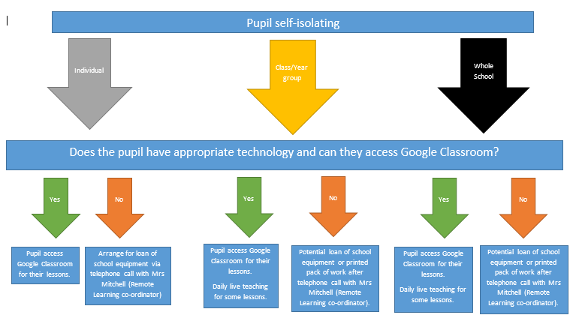
Setting work each lesson on Teams and delivering Teams lessons:
  - Teachers will set work for their classes daily and it may be necessary to set work for colleagues unable to work.
  - The amount of work set should be able to be completed in the curriculum time allocated that day
  - Work should be set by 7pm the day before and placed on Teams.
  - Year group teachers should aim for the live or recorded, online delivery part of lessons to last between 20 and 30 minutes and should deliver English and Maths live sessions daily.
  - Pupil attendance to online lessons should be recorded each day and the teachers will register the pupils at 9am each day.
  - All work set should be uploaded on Teams and avoid unnecessary printing out at home. Most of the work set should be able to be uploaded directly or a photograph taken and uploaded. If work is done over a longer period of time (i.e.Art project) then the children will be given a workbook to complete their work and return to class after the isolation/lockdown period.
  - Teachers will ensure that their pupils have internet access at home and suitable devices to be able to access the learning. Teachers need to provide paper-based tasks for any pupil who has limited access to technology or the internet
  - Teachers will reward pupils who are working hard and acknowledge effort being made to complete tasks, primarily using team points.
Providing feedback:
Providing timely and helpful feedback is a cornerstone of good teaching and learning, and whilst this may be more challenging with remote learning, teachers will endeavour to provide regular feedback to pupils on pieces of work that they are required to submit. Under normal circumstances, not all pieces of work are formally assessed by teachers and this would continue to be the case should the school employ remote learning.
Feedback will be provided in line with our normal policy, allowing for the use of Teams and can be delivered through: whole class feedback, individual feedback and online quizzes that may self-mark or allow for extended answers.
The feedback to pupils should be timely and records of pupil engagement and learning will be kept and, where appropriate, shared. Where pupils do not appear to be engaging, parents/carers will be contacted by staff. Good work and effort should be rewarded in line with the Rewards Policy.
Staff will endeavour to remain in touch with pupils who aren’t in school and their parents/carers and if there is a period of prolonged (partial) school closure of more than 14 days, teachers will ensure they make contact with every pupil at least once every two weeks. These contacts may be via Teams sessions. Our wonderful teaching assistants will also support remote learning and will participate in the lessons daily. They may also participate in pastoral telephone calls.
Any staff unable to make contact with specific pupils will log this as a safeguarding concern. Where pupils or parents/carers have a concern, teachers will endeavour to resolve the issue and can be raised through our pastoral lead.

Attending virtual meetings with staff, parents/carers and pupils:
  - Staff are expected to attend and participate in virtual meetings as appropriate. These may include year group and whole school meetings
  - Staff should be dressed appropriately according to the dress code
  - Staff should be aware of the location that virtual meetings are held e.g. avoid areas with background noise, nothing inappropriate in the background (some devices allow the background to be blurred)
Teaching assistants
When assisting with remote learning, teaching assistants must be available for their usual working hours.
If they’re unable to work for any reason during this time, for example due to sickness or caring for a dependent, they should report this using the normal absence procedure.
Staff must act in line with the Staff Code of Conduct.
Subject Leaders
Alongside their teaching responsibilities, Subject Leaders will continue to be responsible for considering whether any aspects of the subject curriculum need to change to accommodate remote learning and alerting staff to resources they can use to teach their subject remotely, including for pupils who find access to appropriate IT difficult.
SENDCo
The SENDCo will work with all her families to ensure that all children on the SEN register are monitored and are able to achieve when learning remotely. She will check that all children with an EHCP have an up to date risk assessment in place when remote learning and make regular contact with these families to offer further wellbeing support. The Pupil Profiles should continue to be achievable for children working from home so that their targets can be met – adapting where necessary for remote learning
Senior Leaders
Senior leaders will be co-ordinating the remote learning approach across the school and monitor the effectiveness of remote learning for all pupils. This may include monitoring the security of remote learning systems, including data protection and safeguarding considerations. They will also be ensuring families have access to hardware and learning support materials and reviewing assignments set and feedback.
Designated Safeguarding leaders / Pastoral Support Leader / Mental Health Leader
- DSL is responsible for any safeguarding considerations as set out in the Child Protection and Safeguarding policy
- Pastoral lead will work with vulnerable families to ensure they have support through remote learning
- Mental Health lead will support staff and pupils to ensure their well-being needs are being met
Pupils and Parents/Carers
Pupils accessing learning remotely should ensure that they:
- Be contactable during the school day – although we do not expect them to always be in front of a device the entire time
- Complete work set by teachers
- Seek help if they need it, from teachers or teaching assistants, through Teams queries
- Parents should let the school know if their child is sick or otherwise can’t complete work
- Parents can seek help from the school if they need it, especially if pupils are unable to access remote learning via the internet
Governors
The Governors will monitor the school’s approach to providing remote learning to ensure education remains as high quality as possible

Who to contact
If parents have any questions or concerns about remote learning, they should contact the following individuals via the office email:
- Issues in setting work – Remote learning Coordinator
- Issues with IT – email the school office
- Issues with their staff workload or wellbeing – Ms Smith
- Concerns about well-being – Mental Health Lead – Mrs Baird or Mrs Macintosh
- Concerns about data protection – Ms Smith
- Concerns about safeguarding – Designated Safeguarding Lead – Ms Smith

Data protection
When accessing personal data for remote learning purposes, all staff members will only access school information using SIMS, CPOMS, Sharepoint and OneDrive. Measures will be taken to ensure access to personal data of staff or pupils is secure and cannot be accessed inappropriately. Staff members may need to collect and/or share personal data as part of the remote learning system. However, staff are reminded to collect and/or share as little personal data as possible online.
Keeping devices secure
All staff and pupils should ensure their devices remain secure. This includes, but is not limited to:
- Keeping devices password-protected and not sharing with others
- Making sure the device logs out if left inactive for a period of time

Monitoring arrangements
This policy will be reviewed annually by the Senior Leaders. At every review, it will be approved by the Governing Body.

Links with other policies and documents
This policy is linked to our:
- Rewards and Behaviour policy
- Safeguarding and Child Protection policy
- Data protection policy and privacy notices
- Concerns and Complaints Procedure
- Internet acceptable use policy
- Staff Code of Conduct
- Parent Code of Conduct

